Example:

This is een video from youtube, one of the providers in the list.
It shows image and you can click on the play button.

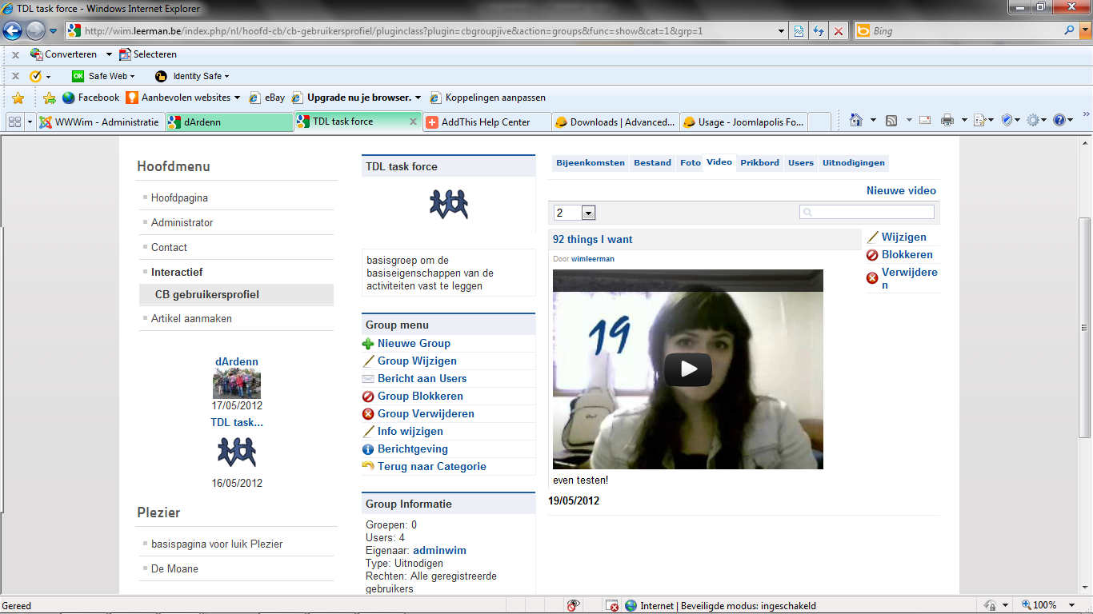

These are examples of movies on dropbox and on Pogoplug.
No image is shown.
However, when I click on ‘test2’ of ‘testje’ (the titles of the movies) they do open in the same window
Dropbox movie: https://www.dropbox.com/s/akn9moy0w4b4w80/VID-20120413-00000.3GP
Pogoplug: http://ppl.ug/RyL1fGKLOFo/

